

CyberShield 360: Design and Analysis of an AI-Enabled Enterprise Cybersecurity Platform
Software Requirement Specification (SRS) document
Submitted in the partial fulfilment for the Course of

CSA1012 – Software Engineering

to the award of the degree of

BACHELOR OF TECHNOLOGY

Submitted by
P.Sai Surya Tej (192572044)

UNDER THE SUPERVISION OF
Dr. K. Anita Davamani

SIMATS ENGINEERING
Saveetha Institute of Medical and Technical Sciences
Chennai-602105
July-2026

ACKNOWLEDGEMENT

We would like to express our heartfelt gratitude to all those who supported and guided us throughout the successful completion of our Capstone Project. We are deeply thankful to our respected Founder and Chancellor, Dr. N.M. Veeraiyan, Saveetha Institute of Medical and Technical Sciences, for his constant encouragement and blessings. We also express our sincere thanks to our Pro-Chancellor, Dr. Deepak Nallaswamy Veeraiyan, and our Vice-Chancellor, Dr. S. Suresh Kumar, for their visionary leadership and moral support during the course of this project.

We are truly grateful to our Director, Dr. Ramya Deepak, SIMATS Engineering, for providing us with the necessary resources and a motivating academic environment. Our special thanks to our Principal, Dr. B. Ramesh for granting us access to the institute’s facilities and encouraging us throughout the process. We sincerely thank our Head of the Department, Dr K. Anita Davamani for his continuous support, valuable guidance, and constant motivation.

We are especially indebted to our guide Dr K. Anita Davamani for his creative suggestions, consistent feedback, and unwavering support during each stage of the project. We also express our gratitude to the Project Coordinators, Review Panel Members (Internal and External), and the entire faculty team for their constructive feedback and valuable inputs that helped improve the quality of our work. Finally, we thank all faculty members, lab technicians, our parents, and friends for their continuous encouragement and support.

Signature With Student Name
P. Sai Surya Tej (192572044)

Abstract

The rapid growth of digital transformation, cloud computing, and interconnected enterprise systems has significantly increased the complexity and frequency of cyber threats. Traditional cybersecurity solutions, which primarily rely on signature-based detection and manual analysis, are no longer sufficient to identify sophisticated attacks such as ransomware, phishing, insider threats, Advanced Persistent Threats (APTs), and zero-day vulnerabilities. Enterprise Security Operations Centers (SOCs) face the challenge of analyzing massive volumes of security logs generated from networks, endpoints, cloud platforms, and applications, resulting in delayed incident detection, fragmented visibility, and slower response times.
This case study presents CyberShield 360, an AI-powered Enterprise Cybersecurity Monitoring and Threat Intelligence System designed to enhance organizational security through intelligent automation and real-time threat detection. The proposed platform integrates Artificial Intelligence (AI), Machine Learning (ML), behavioral analytics, and global threat intelligence feeds to continuously monitor enterprise infrastructure, detect anomalous activities, predict potential cyber threats, and automate incident response. By correlating security events from multiple sources, the system minimizes false positives, improves threat visibility, and enables proactive security management.
The proposed solution follows software engineering principles such as modularity, scalability, maintainability, reliability, usability, and security to ensure the development of a robust and enterprise-ready cybersecurity platform. An Agile Scrum development methodology integrated with DevSecOps practices is recommended to support continuous development, rapid deployment, and evolving security requirements. The platform includes modules for data collection, AI-based threat detection, threat intelligence integration, automated response, compliance management, and interactive security dashboards.
The expected outcomes of CyberShield 360 include faster threat detection, reduced incident response time, improved regulatory compliance, enhanced protection against advanced cyberattacks, and greater operational efficiency for security teams. Although challenges such as implementation cost, AI model maintenance, legacy system integration, and privacy concerns remain, the proposed platform provides a scalable and intelligent approach to strengthening enterprise cybersecurity. Overall, CyberShield 360 demonstrates how AI-driven technologies and software engineering practices can be combined to build a modern, resilient, and proactive cybersecurity solution capable of addressing the evolving threat landscape.

1. Introduction
This Software Requirement Specification (SRS) document defines the functional and non-functional requirements for CyberShield 360, an AI-based enterprise cybersecurity monitoring and threat intelligence system. It provides a clear description of the problem context, business objectives, system scope, constraints, and validation criteria to guide design, implementation, and evaluation.

2. Overall Description and Business Context
CyberShield 360 operates in the domain of enterprise cybersecurity, threat intelligence, and incident response management. Modern organizations generate massive volumes of heterogeneous security data from networks, endpoints, applications, and cloud environments. At the same time, they face increasingly sophisticated threats such as ransomware, targeted phishing, and insider misuse. Traditional signature-based tools and manual workflows are insufficient to keep pace with this landscape, which motivates a unified, intelligent, and automated monitoring platform.
- Business Domain: Enterprise Cybersecurity, Threat Intelligence, and Incident Response Management.
- Key Existing Challenges: High volume of security logs; advanced ransomware and phishing; difficulty detecting insider threats and lateral movement; lack of integrated, real-time threat intelligence.
- System Objectives: 24/7 automated monitoring across enterprise assets; use of AI/ML for accurate threat detection; reduction of Mean Time to Detect (MTTD) and Mean Time to Respond (MTTR); and support for regulatory compliance and business continuity through automated reporting and response.

3. Stakeholders and User Classes
- Security Analysts: Primary users who monitor alerts, review analytics, and manage incident responses.
- IT Managers / System Administrators: Responsible for deploying, configuring, and integrating CyberShield 360 with existing infrastructure.
- Compliance Officers and Auditors: Use the system to access evidence and reports for standards such as GDPR, HIPAA, and PCI-DSS.
- Executives (e.g., CISO, CTO): Consume high-level dashboards and risk metrics to understand organizational security posture and make strategic decisions.

4. System Scope and Objectives
The scope of CyberShield 360 is to provide end-to-end monitoring, detection, and response capabilities across networks, endpoints, cloud resources, and user activities, augmented by external threat intelligence. The system must support the entire incident lifecycle—from detection and prioritization to automated and analyst-driven response—while offering analytics and compliance support suitable for large-scale enterprise environments.
- Continuously monitor internal network traffic, endpoint devices, cloud-based resources, and user activities.
- Ingest and normalize diverse system logs and external threat intelligence feeds into a unified analytical view.
- Automate incident detection, prioritization, and response workflows while allowing analyst overrides where necessary.
- Provide dashboards, reports, and evidence to support regulatory compliance and security oversight.

5. Functional Requirements
This section enumerates the core functional requirements for CyberShield 360. Requirements FR1–FR12 are numbered for clarity and traceability.
- FR1: The system shall continuously monitor and analyze all internal and external network traffic for anomalous patterns.
- FR2: The system shall monitor endpoint devices (workstations, servers) for unauthorized file changes and process executions.
- FR3: The system shall integrate with cloud platforms (AWS, Azure, GCP) to monitor resource configurations and access logs.
- FR4: The system shall track user activity logs to identify potential insider threats and credential misuse.
- FR5: The system shall ingest and normalize system logs from firewalls, routers, and application servers.
- FR6: The system shall utilize AI/ML models to detect malware, phishing attempts, and ransomware signatures.
- FR7: The system shall integrate real-time threat intelligence feeds from external providers.
- FR8: The system shall automatically prioritize detected incidents based on asset criticality and threat severity.
- FR9: The system shall trigger automated response workflows, such as isolating infected hosts or blocking malicious IPs.
- FR10: The system shall provide a centralized dashboard for real-time security visualization and analytics.
- FR11: The system shall support the generation of compliance reports for standards such as GDPR, HIPAA, and PCI-DSS.
- FR12: The system shall allow security analysts to manually override automated response actions.
Key functional features derived from these requirements include an AI-based threat detection engine, automated incident response orchestration, a unified security analytics dashboard, and real-time threat intelligence integration.
ID | Requirement Description
FR1 | The system shall continuously monitor and analyze all internal and external network traffic for anomalous patterns.
FR2 | The system shall monitor endpoint devices (workstations, servers) for unauthorized file changes and process executions.
FR3 | The system shall integrate with cloud platforms (AWS, Azure, GCP) to monitor resource configurations and access logs.
FR4 | The system shall track user activity logs to identify potential insider threats and credential misuse.
FR5 | The system shall ingest and normalize system logs from firewalls, routers, and application servers.
FR6 | The system shall utilize AI/ML models to detect malware, phishing attempts, and ransomware signatures.
FR7 | The system shall integrate real-time threat intelligence feeds from external providers.
FR8 | The system shall automatically prioritize detected incidents based on asset criticality and threat severity.
FR9 | The system shall trigger automated response workflows, such as isolating infected hosts or blocking malicious IPs.
FR10 | The system shall provide a centralized dashboard for real-time security visualization and analytics.
FR11 | The system shall support the generation of compliance reports for standards such as GDPR, HIPAA, and PCI-DSS.
FR12 | The system shall allow security analysts to manually override automated response actions.
Feature 1 | AI-Based Threat Detection Engine
Feature 2 | Automated Incident Response Orchestration
Feature 3 | Unified Security Analytics Dashboard
Feature 4 | Real-time Threat Intelligence Integration

6. Non-Functional Requirements
Non-functional requirements specify the quality attributes and operational constraints that CyberShield 360 must satisfy.

6.1 Performance
- The system shall process and analyze network events with a latency of less than 100 milliseconds.

6.2 Security
- All sensitive data, including logs and threat intelligence, shall be encrypted at rest and in transit using AES-256 and TLS 1.3.

6.3 Availability
- The system shall ensure 99.9% availability during business hours to support continuous monitoring.

6.4 Scalability
- The system architecture shall support horizontal scaling to handle up to 1 million events per second.

6.5 Usability
- The user interface shall be designed to allow a trained security analyst to identify a critical alert within 3 clicks.

6.6 Maintainability
- The system shall allow for the update of AI models and threat feeds without requiring a full system restart.
Category | Requirement Description
Performance | The system shall process and analyze network events with a latency of less than 100 milliseconds.
Security | All sensitive data, including logs and threat intelligence, shall be encrypted at rest and in transit using AES-256 and TLS 1.3.
Availability | The system shall ensure 99.9% availability during business hours to support continuous monitoring.
Scalability | The system architecture shall support horizontal scaling to handle up to 1 million events per second.
Usability | The user interface shall be designed to allow a trained security analyst to identify a critical alert within 3 clicks.
Maintainability | The system shall allow for the update of AI models and threat feeds without requiring a full system restart.

7. System Actors and Use Cases
CyberShield 360 involves both human and system actors. The primary actor is the Security Analyst, supported by system-level services and external data providers.
- Security Analyst (primary): Interacts with dashboards, investigates alerts, and approves or adjusts response actions.
- System Administrator: Manages configuration, integrations (e.g., SIEM, cloud accounts), and user access control.
- Automated Response Engine (system actor): Executes predefined response workflows based on incident severity and policies.
- External Threat Intelligence Provider: Supplies real-time indicators of compromise and threat context to the platform.
Key use cases include detecting threats based on AI analysis of logs, responding automatically to high-severity incidents by isolating compromised endpoints, and enabling analysts to review historical analytics and trends in phishing or other attack types.
Element | Description
Actors | 1. Security Analyst (Primary) 2. System Administrator 3. Automated Response Engine (System Actor) 4. External Threat Intel Provider.
UC1: Detect Threat | Actor: System. Description: The AI engine analyzes incoming logs and identifies a ransomware pattern, flagging it as a critical incident.
UC2: Respond to Incident | Actor: Automated Response Engine. Description: Upon detection of a high-severity threat, the system automatically isolates the compromised endpoint from the network.
UC3: Review Analytics | Actor: Security Analyst. Description: The analyst reviews the weekly security posture report and identifies trends in phishing attempts.

8. Use Case Diagram Description
In the conceptual use case diagram, the Security Analyst actor is connected to the "Monitor Dashboard" and "Manage Alerts" use cases, representing interactive monitoring and manual incident handling. The Automated Response Engine is associated with the "Trigger Response Workflow" use case, indicating system-driven mitigation actions such as host isolation or IP blocking. The External Threat Intelligence Provider is linked to the "Update Intelligence" use case, where new indicators and threat data are ingested into CyberShield 360. Together, these interactions depict how human analysts, automated components, and external data sources collaborate to detect, prioritize, and respond to threats.
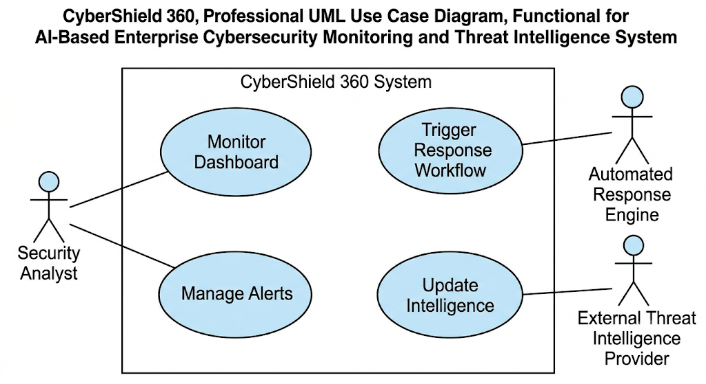

9. Data Requirements
CyberShield 360 depends on a rich set of structured and semi-structured data sources to support monitoring, analytics, and response.
- Structured log data (e.g., JSON, Syslog) from firewalls, routers, servers, applications, and security tools.
- Network flow records (e.g., NetFlow) describing communication patterns between internal and external hosts.
- Threat indicators (e.g., in STIX/TAXII formats) from external threat intelligence providers.
- Cloud configuration and access logs from supported cloud platforms for posture and access monitoring.

10. Assumptions
- The enterprise network provides sufficient visibility into traffic to support effective monitoring.
- External threat intelligence feeds are reliable, timely, and relevant to the organization’s threat landscape.
- Existing endpoints support the installation and operation of required monitoring agents where necessary.
Constraint Type | Description
Assumptions | 1. The enterprise network provides full visibility into traffic. 2. External threat intelligence feeds are reliable and timely. 3. Existing endpoints support the installation of monitoring agents.

11. Constraints
- Technical Constraints: The system must be compatible with Linux-based server environments and integrate with existing SIEM tools via REST APIs.
- Operational Constraints: A 24/7 Security Operations Center (SOC) is required to monitor and handle high-priority alerts that need manual intervention.
- Economic Constraints: The total cost of ownership, including cloud infrastructure and licensing, must not exceed the annual security budget.
- Legal Constraints: The system must comply with international data privacy laws (such as GDPR) regarding the storage and processing of user activity logs.
- Time Constraints: The Minimum Viable Product (MVP) must be deployed and operational within 180 days of project kickoff.
Technical Constraints | The system must be compatible with Linux-based server environments and support integration with existing SIEM tools via REST APIs.
Operational Constraints | The system requires a 24/7 Security Operations Center (SOC) for monitoring high-priority alerts that require manual intervention.
Economic Constraints | The total cost of ownership, including cloud infrastructure and licensing, must not exceed the annual security budget.
Legal Constraints | The system must comply with international data privacy laws (GDPR) regarding the storage of user activity logs.
Time Constraints | The Minimum Viable Product (MVP) must be deployed and operational within 180 days of project kickoff.

12. System Architecture and Components (High-Level)
While this SRS does not prescribe a specific implementation architecture, the requirements imply several major functional components that should be represented in the high-level design.
- Data Ingestion and Normalization Layer: Collects logs, network flows, and threat intelligence; normalizes data into a common schema.
- AI-Based Analytics Engine: Applies machine learning models to detect anomalous patterns, malware, phishing, and ransomware indicators.
- Incident Management and Response Orchestrator: Prioritizes incidents based on asset criticality and severity, and executes automated response workflows.
- Security Analytics Dashboard: Provides real-time visualization, alert management, and historical reporting for analysts and executives.
- Integration Interfaces: Support connectivity with cloud platforms, SIEM tools, and external threat intelligence providers via standard APIs.
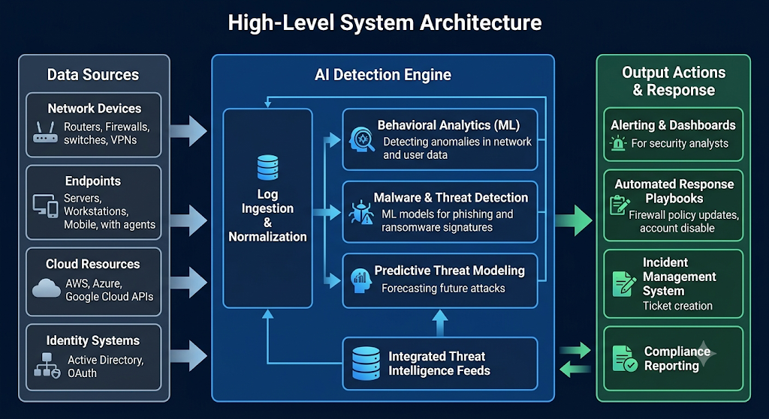

13. Performance and Scalability Requirements
CyberShield 360 must operate effectively in large-scale enterprise environments, handling high-volume event streams with low latency and the ability to scale horizontally.
- The system shall process and analyze network events with a latency of less than 100 milliseconds (Performance).
- The system architecture shall support horizontal scaling to handle up to 1 million events per second (Scalability).

14. Security and Compliance Requirements
Given its role in enterprise cybersecurity, CyberShield 360 must implement strong security controls for its own operation and support compliance with relevant regulations.
- All sensitive data, including logs and threat intelligence, shall be encrypted at rest and in transit using AES-256 and TLS 1.3.
- The system shall support the generation of compliance reports aligned with standards such as GDPR, HIPAA, and PCI-DSS.
- The system must comply with international data privacy regulations (e.g., GDPR) for storage and processing of user activity logs.

15. Availability, Maintainability, and Usability
The platform must be sufficiently available for continuous monitoring, support efficient operations by security teams, and remain maintainable as threats and models evolve.
- Availability: The system shall ensure 99.9% availability during business hours to support continuous monitoring.
- Maintainability: The system shall allow for updating AI models and threat feeds without requiring a full system restart.
- Usability: The user interface shall enable a trained security analyst to identify a critical alert within 3 clicks.

16. Requirement Validation Analysis
Validation Criteria | Analysis and Improvements
Completeness | The requirements cover all aspects of monitoring, detection, and response as specified in the project summary.
Consistency | Functional requirements for automated response are consistent with non-functional performance and security constraints.
Ambiguity | Terms like 'real-time' and 'anomalous' are quantified in the non-functional requirements to ensure clarity.
Redundancy | Duplicate monitoring requirements across network and endpoint sections have been consolidated into unified monitoring FRs.
Improvements | Future iterations should include predictive analytics for proactive threat hunting and deeper integration with identity providers.
- The requirement set is judged complete with respect to monitoring, detection, response, and compliance support described in the project overview.
- Consistency checks confirm alignment between automated response functions and non-functional constraints around performance, security, and availability.
- Ambiguous terms (e.g., real-time, anomalous) have been refined or supported by explicit non-functional requirements.
- Redundant or overlapping monitoring requirements have been consolidated into unified functional requirements for clarity and maintainability.

17. Future Improvements and Extensions
- Incorporate predictive analytics capabilities for proactive threat hunting and early risk identification.
- Deepen integration with identity and access management providers to enhance user- and role-based anomaly detection.
- Extend analytics and reporting to cover additional regulatory frameworks as needed by adopting organizations.

18. Conclusion
CyberShield 360 is specified as a state-of-the-art AI-driven cybersecurity monitoring and threat intelligence platform tailored for large-scale enterprise environments. The requirements in this SRS define a system that unifies data ingestion, analytics, incident response, and compliance support to address the complexities of modern cyber threats. By meeting the functional and non-functional requirements outlined above, CyberShield 360 can significantly strengthen organizational security posture while supporting efficient operations and regulatory obligations.

